***CHAPTER 7: Strategy and Strategic Management***

Strategic Management: proactive planning

**Competitive Advantage:** operating with an attribute or set of attributes that allows an organization to outperform its rivals, to perform better than the competition

**Sustainable competitive advantage:** one that is difficult for competitors to imitate. (ex: Mozilla’s open source networks allow for continual improvements)

* **Cost and Quality:** operating with greater eﬃciency and product or service quality
* **Knowledge and Speed:** emphasis on innovation and speed of delivery to market for new ideas
* **Barriers to entry:** creating a market stronghold that is protected from entry by others
* **Financial resources:** having better investments or loss absorption potential than competitors
* **Technology:** using technology to gain operating efficiencies, market exposure, or customer loyalty.

**Strategy:** a comprehensive action plan that identifies long-term direction for an organization and guides resource utilization to accomplish organizational goals with sustainable competitive advantage. “best guess” of future success.

* Long term strategy becomes even shorter in a world of changing technologies and globalization
* Must come up with strategies that are driven by customers and economic realities

**Strategic intent:** focusing all organizational energies on a unifying and compelling goal (Ex: Coca-Cola focuses on JUST making Coke, because their goal is to become the top at that)

Goal of strategic management is to create above-average returns for investors:

* Returns exceeding those for alternative opportunities at equivalent risk
* Earning above-average returns depends in part on the organization’s competitive environment

**Strategic Management Process:**

* **Strategic management:** the process of formulating and implementing strategies to accomplish long-term goals and sustain competitive advantage
* **Strategic analysis:** process of analyzing the organization, the environment, its competitive position and current strategies
* **Strategy formulation:** the process of crafting strategies to with the goal of sustainable competitive advantage
* **Strategy implementation:** putting strategies into action

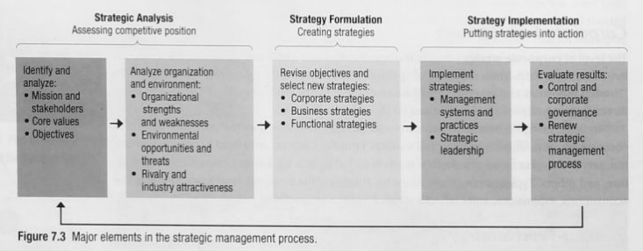

**Essentials of Strategic Analysis:**

* **Analysis of mission:**

1. The reason for an organization’s existence.
2. An important test of the mission is how well it serves the organization’s stakeholders.

* **Analysis of core values:**

1. Values are broad beliefs about what is or is not appropriate.
2. Organizational culture reflects the dominant value system of the organization as a whole.
3. Expected for firm of an organization to live up to the values.

* **Strong core values:**

1. Helps build organizational identity.
2. Gives character to the organization in the eyes of employees and external stakeholders.
3. Backs up the mission statement.
4. Guides the behavior of organizational members in meaningful and consistent ways.

* **Analysis of objectives:** Operating objectives direct activities toward key and specific performance results.

1. Profitability (operating with net profit)
2. Market share
3. Human Talent (high quality workforce)
4. Financial Health (earn positive returns)
5. Cost efficiency (use resources well at low cost)
6. Product quality
7. Innovation
8. Social responsibility (positive contribution to society)

**SWOT Analysis of Organization and environment:** Analyze the organization and its environment

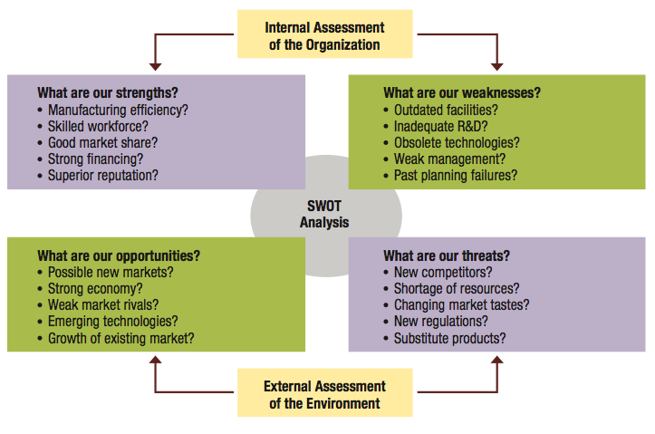

**SLIDES:** Have JSMB as an example

**Core Competencies:** things that the organization has or does exceptionally well in comparison with competitors:

* Important goal of assessing core competencies
* Potential core competencies: special knowledge or expertise, superior technology, efficient manufacturing approaches, unique product distribution systems

**Porter’s Model of Five Strategic forces affecting competition:**

* Industry Competition: the intensity of rivalry among firms and their competitive behavior
* New entrants: the threat of new competitors entering the market
* Substitute products or services: the threat of substitute products or services
* Bargaining power of suppliers: the ability of resource suppliers to influence the cost of products or services
* Bargaining power of customers: the ability of customers to influence the price they will pay for products or services

**Porter’s generic business-level strategies framework: soft-drink industry examples:**

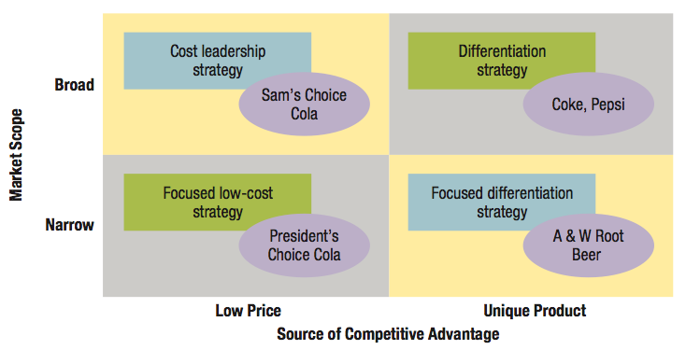

**Corporate level Strategies:**

**Concentration:** an approach for growth, expansion is within the same business area (ex: Tim Hortons, Canadian Tire)

**Diversification:** an approach for growth, expansion takes places in new and different business areas.

**Vertical Integration:** business acquires suppliers or distributors (ex: PepsiCo and Coca Cola have purchased some of their major bottlers.

**Focus Strategy:** concentrates on serving a unique market segment better than anyone else.

**Focus – Cost differentiation:** firm sells a unique product to a special niche market

Competitive advantage is achieved by combining focus with either differentiation or cost leadership.

**Focused cost leadership:** seeks lowest cost of operation within a special market segment (ex: carriers offer discounted fares to airlines)

**Strategic planning failures that hinder strategy implementation:**

* Failures of substance: Inadequate attention to major strategic planning elements
* Failures of process: poor handling of strategy implementation (lack of participation, over-planning)

**Corporate governance:**

* System of control and performance monitoring of top management
* Exercised by boards of directors and other major stakeholder representatives
* Make sure organization operates in the best interests of its owners
* Boards may be too compliant in endorsing or confirming the strategic initiatives of top management

**Strategic Control:**

* Make sure strategies are well implemented
* Poor strategies are scrapped or modified to quickly meet the performance demands

**Strategic leadership:**

* Capability to inspire people to successfully engage in a process of continuous change, performance enhancement and implementation of organizational strategies.
* A strategic leader has to maintain strategic control (should always be in touch with the strategy)

1. **A strategic leader has to be the guardian of trade-oﬀs:** It is the leader’s job to make sure that the organization’s resources are allocated in ways consistent with the strategy. It requires the discipline to sort through many competing ideas and alternatives, to stay on course, and not to get sidetracked
2. **A strategic leader needs to create a sense of urgency:**The leader can’t allow the organization and its members to grow slow and complacent. Even when doing well, the leader keeps the focus on getting better and being alert to conditions that require adjustments to the strategy
3. **A strategic leader needs to make sure that everyone understands the strategy:** Unless strategies are understood, the daily tasks and contributions of people lose context and purpose. Everyone might work very hard, but without alignment to strategy the impact is dispersed and fails to advance common goals
4. **A strategic leader needs to be a teacher:** It is the leader’s job to teach the strategy and make it a “cause.” In order for strategy to work it must become an ever-present commitment throughout the organization. Tis means that a strategic leader must be a great communicator. Everyone must understand the strategy and how it makes their organization diﬀerent from others